SYSTEM ARCHITECTURE:

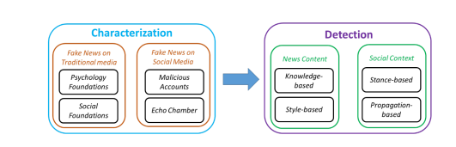

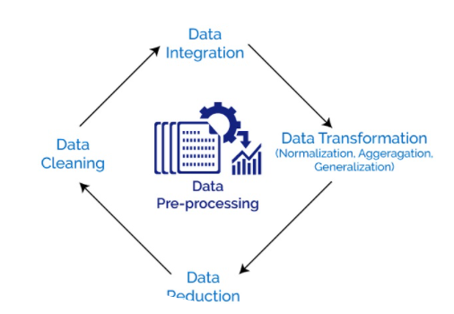

Data flow:

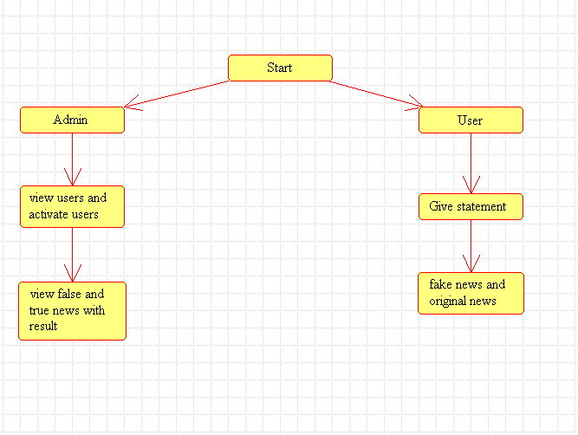

Activity:

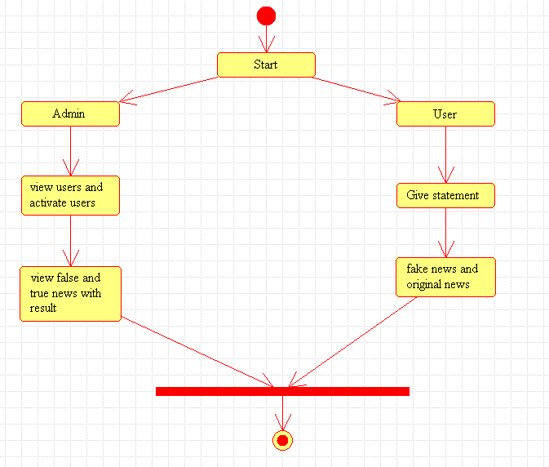

Use case:

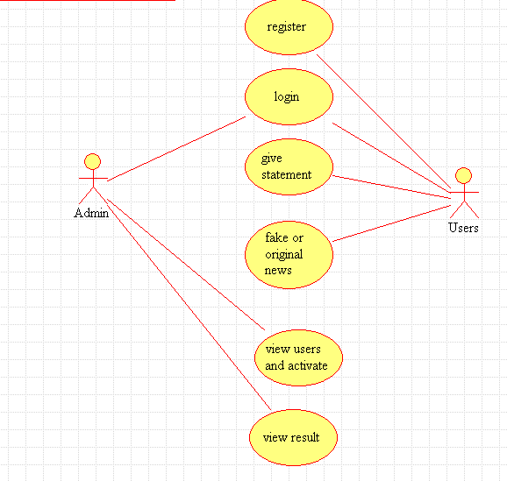

Class:

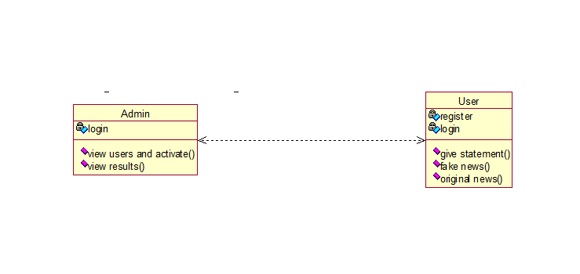

ER-Diagram:

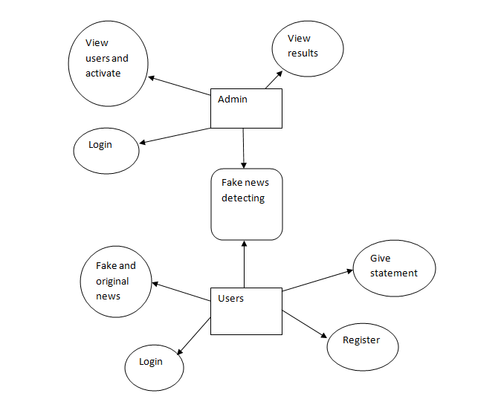

**SEQUENCE DIAGRAM:**

A sequence diagram in Unified Modeling Language (UML) is a kind of interaction diagram that shows how processes operate with one another and in what order. It is a construct of a Message Sequence Chart. Sequence diagrams are sometimes called event diagrams, event scenarios, and timing diagrams.

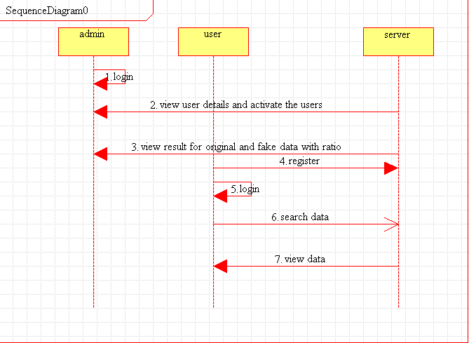

Object diagram:

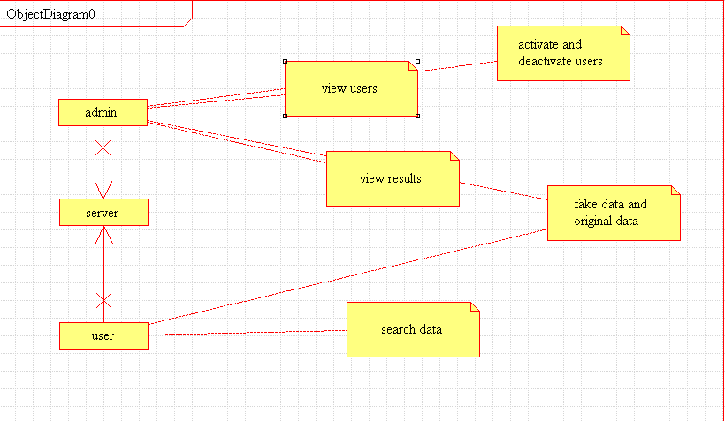

Collaboration:

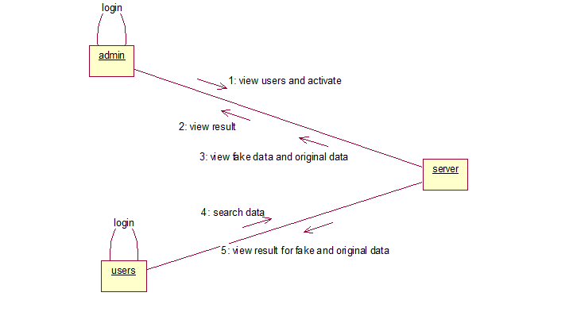

Object diagram:

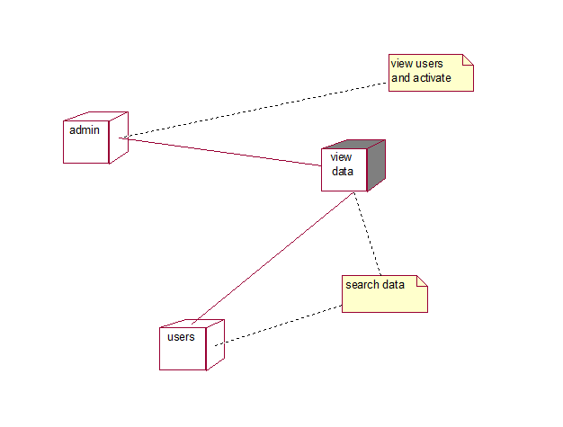

Component:

